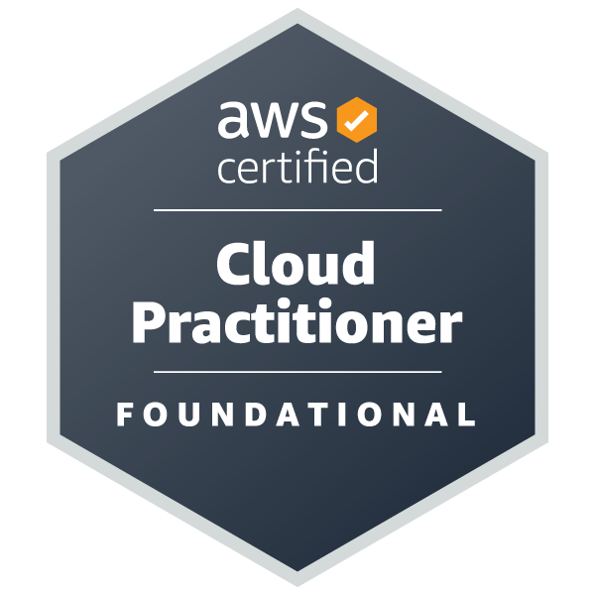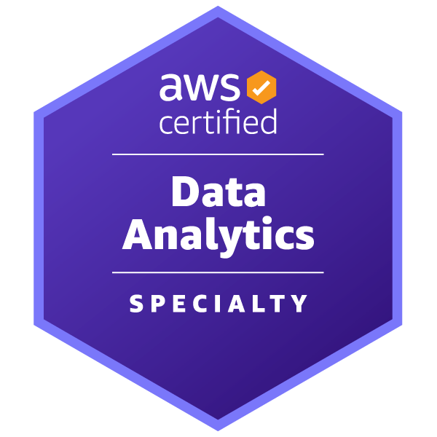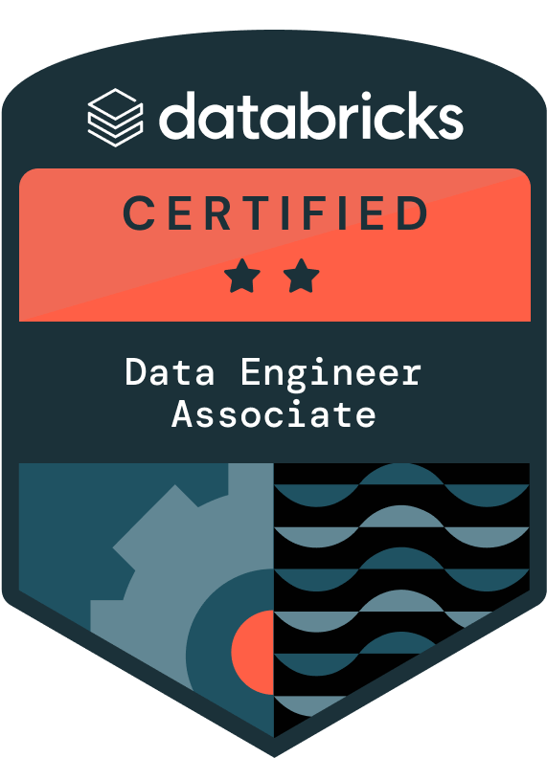

Shruthi G
Bay Area/ Remote Only
Email: santosh@viratsolutions.com
+1 972-924-5835 (Employer),
C2C Only, H4 EAD (Passport Number also shared)
SUMMARY OF QUALIFICATIONS

- 9+ years of experience in Data Engineering, Software Development and Project Management across Retail, Manufacturing, and Supply Chain services.
- Proficient in leveraging Azure Databricks, Matillion, Snowflake & AWS Glue to process large datasets, ensuring optimized data integration and transformation.
- Strong knowledge of advanced analytical, data model design, development techniques using SQL, Python, and ETL tools.
- Expert in implementing automated data validation using Python & Snowflake, ensuring 99.8% data accuracy and reducing reconciliation time by 40%.
- Experience in optimizing Snowflake query performance using partitioning, clustering, indexing, and SnowSQL, reducing query execution time by 30%.
- Comprehensive knowledge in AWS Cloud technologies – EC2, S3, Lambda, API, Athena, Glue, SQS, SNS.
- Experienced in leading projects and collaborating with cross-functional teams to deliver data-driven solutions.
- Strong understanding of complete Software Development Life Cycle (SDLC), involving both technical implementation and project coordination.
- Innate ability to deliver meaningful insights using BI Tools(Tableau, PowerBI) and communicate clearly with the cross-functional teams & stakeholders.
SKILLS

- Programing Languages: Python, SQL, PySpark
- Databases: Snowflake, BigQuery, MySQL, PostgreSQL, Oracle
- Cloud Technologies: AWS EC2, Lambda, S3, SQS, SNS, API Gateway, Azure Databricks
- ETL Tools: AWS Glue, Matillion, Athena, Talend, Dbt, SnapLogic
- BI Tools: Tableau, Power BI, AWS QuickSight, Google Data Studio
- Project Management: JIRA, Confluence

WORK EXPERIENCE

TalktoData AI, Santa Clara, CA – Senior AI Engineer Dec’24- Present
- Architected and built a resilient AI data analysis agent using GPT-4 APIs, enabling natural-language querying across Databricks SQL warehouses, Delta Lake tables, and file-based data sources on S3.
- Built a modular agentic architecture with MCP servers, specialized sub-agents, and tool functions for dynamic query planning, schema introspection, and multi-step reasoning over Databricks metadata.
- Integrated Databricks Unity Catalog for schema discovery, access control, and lineage-aware retrieval in GenAI workflows.s
- Developed a comprehensive evaluation framework using LangSmith, running iterative experiments on accuracy, latency, and hallucination rates to continuously improve assistant quality.
- Engineered AWS-native, cloud-scale GenAI APIs and microservices (API Gateway, Lambda/ECS, S3, IAM) serving 110,000+ users with high availability and secure data access.
- Built a GenAI operations and reporting assistant using LangChain + OpenAI that enabled stakeholders to ask natural-language questions over LMS KPIs (enrollment, completion, engagement, SLAs, backlog).
Environment:
AWS, Databricks, Delta Lake, Unity Catalog, OpenAI (GPT-4), Lang Chain, RAG, Vector Databases

McKinsey , CA, US - Senior Data Engineer Jan’23 – Nov’24
- Led Data Engineering initiatives for a Learning Management System serving 50,000+ employees, resulting in 40% improved data accessibility and faster decision-making for stakeholders.
- Spearheaded the migration from SnapLogic to AWS Glue, enhancing real-time reporting and analytical capabilities.
- Built efficient data transformation frameworks with PySpark, Python, and SQL, connecting Oracle/MySQL sources to Snowflake/S3 destinations.
- Architected end-to-end AWS Cloud ETL pipelines (Glue, Athena, Lambda, API Gateway, Snowflake), reducing reporting latency from hours to minutes.
- Utilized AWS Glue Crawlers/data catalogs and Glue ETL for categorizing, cleaning, and enriching data, ensuring reliable movement between various data stores.
- Developed PySpark, Lambda functions for serverless processing between S3 and SFTP, handling daily data transfers.
- Developed Infrastructure-as-Code (IaC) solutions using Terraform, reducing manual provisioning by 60%.
- Collaborated with cross-functional teams to streamline communication & ensure project timelines were met.
Environment:
Snowflake, AWS Glue, Athena, API Gateway, S3, SnapLogic, PySpark, Oracle, MySQL
DataFlix, CA, US – Data Engineer Oct’21 – Jan’23
- Led design and development of ETL pipelines for multi-channel marketing data consolidation for Dataflix
using Matillion.
- Refactored Data Warehouse ETL jobs in Matillion and migrated to the cloud platform, reducing operational
costs by 35%.
- Created reusable Matillion frameworks for cross-platform marketing data migrations from social media,
CRM, and web analytics sources.
- Utilized Matillion's orchestration capabilities to automate complex transformation workflows for campaign
performance metrics.
- Leveraged Matillion and PySpark for large-scale marketing analytics, optimizing performance for executive
dashboards in Sisense.
- Engineered Matillion ETL jobs with parameterized variables and reusable components for faster marketing
data integration.
- Designed and managed various orchestration job types in Matillion, including data ingestion, workflow
sequencing, error handling, data quality validation, and environment-based deployments, ensuring reliable
and scalable ETL pipeline execution across development and production systems.
- Developed and optimized transformation jobs in Matillion, including data cleansing, joining, aggregation,
enrichment, schema restructuring, and change data capture (CDC), enabling efficient data processing and
seamless loading into Snowflake for analytics and reporting.
- Collaborated with marketing teams to analyze requirements and develop Sisense dashboards that improved
campaign ROI visibility.
Environment:
Matillion, Snowflake, Sisense, Marketing Platforms.

Factory Market Retail GmbH, Berlin, Germany – Data Engineer Feb’20 - Sep’21
- Worked in Data & Marketing Analytics team to build brand-new marketing data model and Click-stream DataMart to help management with real-time reporting and analytical capabilities.
- Interacting with marketing stakeholders on delivering live dashboards and reports and to recommend best remediation strategies to ensure pristine quality of high-priority usage data elements.
- Building various analytical visualizations using Power BI, Google Data Studio, Excel, and Python plotting libraries.
- Used AWS Glue Crawler/data catalog to categorize, clean and enrich data and move reliably between various data stores
- Developed Python scripts in a Lambda function for data cleaning and transformations on streaming data.
- Performed extensive data quality and accuracy checks on data warehouse tables and regular loading jobs.
- Frequent collaboration with end-users to do Requirement analysis, bug fixing and enhancing the rest end points in the application systems.
- Constant collaboration with Product, Operations teams and participating in daily scrum meetings and estimating tasks.
Environment:
AWS Glue, Lambda, PowerBI, Google Data Studio, Python, Advanced Excel

Sphinx Pvt Ltd, Bengaluru, India – Business Data Analyst Nov’17 – Dec’19
- Worked in a team of 7 members and contributed to the data, business analysis and reporting on various application data sources to help drive decisions making in product and management divisions.
- Write SQL queries on Snowflake data warehouse to create data blends and design Power BI, AWS QuickSight reports and dashboards to publish audit violation reports and Key Performance Indicators (KPI) to stakeholders and executives
- Responsible for Database table schema definitions, Development and Performance tuning of applications and SQL queries.
- Coordinate with Quality Assurance teams to understand issues identified during other test cycles like integration performance and regression tests.
- Tracking health of sprint using JIRA tool which is a bug tracking system to track and maintain the history of bugs/issues on everyday basis
- Working on agile methodology and attending daily stand-up meetings to achieve the project development timelines
- Knowledge in all types of Database migrations with all the versions of SQL Server
Environment:
Snowflake, Advanced Excel, MS SQL Server, MySQL, Power Bi, AWS Quick Sight, JIRA, Trello

Dell International (NTT Data), India–Technical Client Associate-Analytics Oct’16 - Nov’17
- Worked with Honeywell and other Supply-Chain clients in Data Analytics division to support management on support service reporting activities
- Designed and developed advanced analytics dashboards for the Global Business Units to drive business decision making.
- Support product development team to resolve the general IT and security issues with the application databases.
- Responsible for specification requirements and make sure the application development is within the scope of specifications.
Environment:
PostgreSQL, Tableau, Talend, Advanced Excel, Google Cloud
CERTIFICATIONS, TRAINING & EXTRAS
AWS Certified Cloud Practitioner (B377C56LBFQ1Q7GP)
AWS Certified Data Analytics – Specialty (UC4E5D4BDE1B17)
Matillion Data productivity Cloud- fac115d8-514c-4eed-a983-7fbba895768b
Matillion ETL Foundation- b1fea584-ef8b-4252-ae5b-fe2a303b31b5

EDUCATION

Sri Venkateshwara College of Engineering (VTU), India, Bachelor’s in Computer Science, 2016

